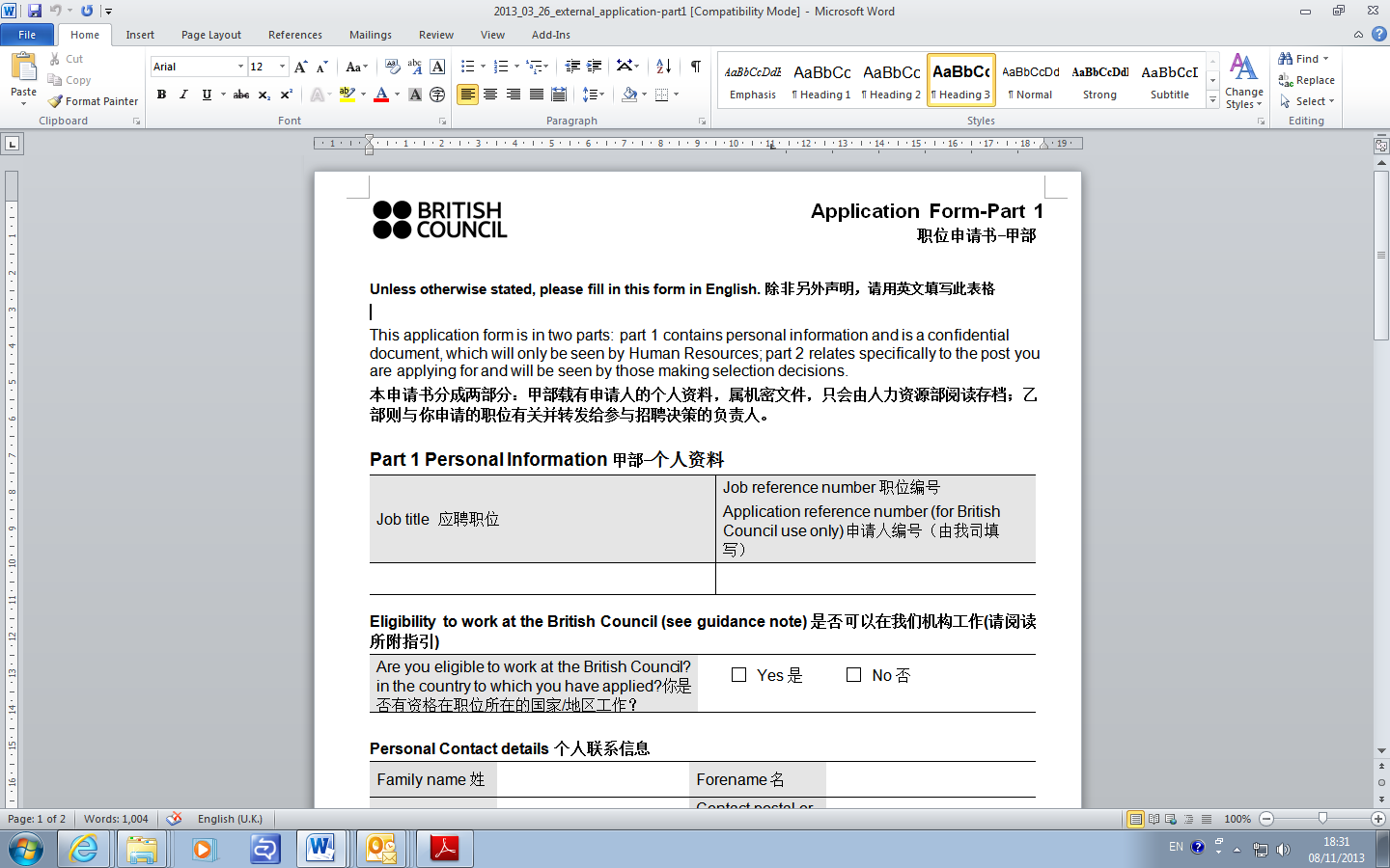

**Unless otherwise stated, please fill in this form in English. 除非另外声明，请用英文填写此表格**

This application form is in two parts: part 1 contains personal information and is a confidential document, which will only be seen by Human Resources; part 2 relates specifically to the post you are applying for and will be seen by those making selection decisions.

**本申请书分成两部分：甲部载有申请人的个人资料，属机密文件，只会由人力资源部阅读存档；乙部则与你申请的职位有关并转发给参与招聘决策的负责人。**

**Part 1 Personal Information甲部-个人资料**

|  |  |
| --- | --- |
| Job title 应聘职位 | Job reference number职位编号  Application reference number (for British Council use only) 申请人编号（由我司填写） |
|  |  |

Eligibility to work at the British Council是否可以在我们机构工作

|  |  |
| --- | --- |
| Are you eligible to work at the British Council? in the country to which you have applied?你是否有资格在职位所在的国家/地区工作？ | Yes 是  No 否 |
| Are you involved or plan to be involved in IELTS teaching in any form? 你是否正在参与或计划参与任何形式的雅思教学或培训工作？ | Yes 是  No 否 |
| Nationality 国籍 |  |

**Personal details 个人信息**

|  |  |  |  |  |  |  |  |  |  |  |  |
| --- | --- | --- | --- | --- | --- | --- | --- | --- | --- | --- | --- |
| Family name姓 |  | | | | Forename 名 | | | |  | | |
| Titile 称谓  (e.g. Mr, Ms, Miss etc) |  | | | | Gender 性别  (Male /Female) | | | |  | | |
| Date of birth  生日 (dd/mm/yyyy) |  | | | | First Language  母语 | | | |  | | |
| Present address  联系地址 |  | | | | Contact postal or email address  邮编或电子邮箱 | | | |  | | |
| Telephone (hm)  家庭电话 |  | | Telephone (wk)  工作电话 | | | |  | | | Mobile手机 |  |
| Can we contact you at work?是否可以在工作时间联系你 | |  | Yes可以 |  | | No  不可以 | |

**Criminal Convictions (see guidance note) 犯罪记录( 请阅读所附指引）**

|  |  |  |  |  |  |
| --- | --- | --- | --- | --- | --- |
| Have you ever been convicted of a criminal offence? 你曾否被刑事定罪？ |  | Yes是 |  | No否 | If yes, please give details of the offence and the sentence imposed: 如答案为‘是’，请详述犯罪事实与判罚。 |

**If you are applying for a job which clearly states involvement with children or young people, or a teaching job, please additionally complete this section.** *As these positions are exempt from the Rehabilitation of Offenders Act 1974, please detail below all convictions, cautions and bindovers, including those regarded as ‘spent’.如果你申请的这个职位清楚地列明工作的内容会涉及到儿童和青少年，请完成此栏。根据1974年的犯罪康复法案，这些人群可以被豁免。请详细在下栏列出所有被定罪，警告或勒令出庭的信息。*

|  |
| --- |
|  |

I declare that I have not been convicted, nor had any criminal proceedings against me, nor have I been warned, either orally or in writing, in relation to a sexual offence or child abuse. I declare that there are no such proceedings pending against me at the date of this declaration. I know of no reason why I should be considered unsuitable for work with children, the elderly or disabled, and I have not been dismissed from such a post for malpractice. 我谨声明我从未因为性侵犯或虐童而被定罪，或引起法律诉讼，或被口头或书面警告。我谨声明时至今日没有任何针对我的类似法律诉讼。我不知道有任何的原因导致我不适合与儿童，老人或残障人士一起工作，我也从没有因为这方面的原因而被除职。

**I agree and hereby consent to the British Council seeking clearance from the CRB or appropriate agency. I understand that the British Council will not carry out these checks unless an offer of employment is made in writing to me.**

**我在此同意贵司从犯罪登记机构或相关部门核实我的无犯罪纪录信息。我理解除非贵司已通过书面形式确认会录用我，否则此种核实不会进行。**

|  |  |  |  |
| --- | --- | --- | --- |
| Your signature/name签名/姓名 |  | Date  日期 |  |

N.B Typing your name will be taken as being as binding as your signature表上键入本人姓名将被视作等同亲笔签名。

|  |  |
| --- | --- |
| Please state where you heard about this vacancy? 你从何处获悉我们的招聘信息？ | |
| British Council colleague 贵司员工  Word of mouth 其他人告诉我  Speculatively browsing British Council website 贵司网站上  Press/Publication advert (please specify) ……………..  平面媒体招聘广告(请注明) | Web advert (please specify) ………………  网站招聘广告(请注明)  Agency (please specify) ……………………  代理/猎头(请注明)  Other (please specify) ……………………  其它(请注明) |

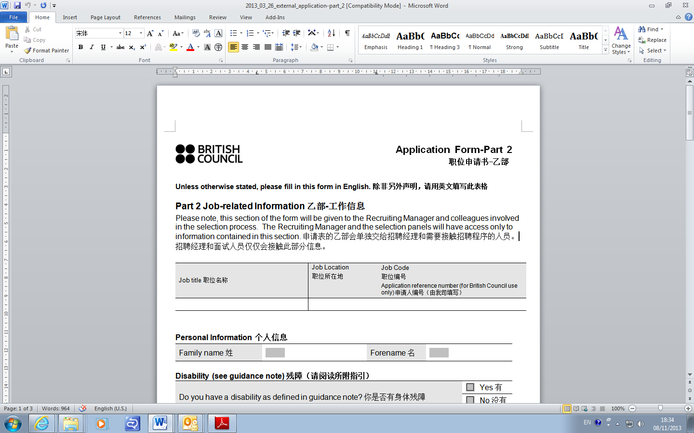

**Unless otherwise stated, please fill in this form in English. 除非另外声明，请用英文填写此表格**

**Part 2 Job-related Information 乙部-工作信息**

Please note, this section of the form will be given to the Recruiting Manager and colleagues involved in the selection process. The Recruiting Manager and the selection panels will have access only to information contained in this section. **申请表的乙部会单独交给招聘经理和需要接触招聘程序的人员。招聘经理和面试人员仅仅会接触此部分信息。**

|  |  |  |
| --- | --- | --- |
| Job title职位名称 | Job Location  职位所在地 | Job Code  职位编号  Application reference number (for British Council use only) 申请人编号（由我司填写） |
|  |  |  |

**Personal Information 个人信息**

|  |  |  |  |
| --- | --- | --- | --- |
| Family name姓 |  | Forename名 |  |

Disability (see guidance note) 残障（请阅读所附指引）

|  |  |  |
| --- | --- | --- |
| Do you have a disability as defined in guidance note? 你是否有身体残障 |  | Yes有 |
|  | No没有 |
| Regardless of whether you have a disability, do you require any adjustments to be made to facilitate your participation in the selection process? If yes, a member of Human Resources will contact you to discuss this at a later date. 无论是否身体残障，你是否需要特别安排以方便你参与此职位的选拔？如果需要，我们人力资源的同事会与你联系确保可以帮助你。 |  | Yes需要 |
|  | No不需要 |

Employment and professional information (see guidance note) 就业和职业信息（请阅读所附指引）

|  |  |  |  |
| --- | --- | --- | --- |
| Date 时间  (From / To) |  | Job title company/organisation  职位，公司/机构 |  |
| Type 工作类型  (Full time / Part time) |  |
| Duties and main achievements in the role. Please limit to 3 main points, max 200 words. 简述工作职责以及所取得的主要成就，请限制在不超过三点，总共不超过100字 |  | | |
| Date 时间  (From / To) |  | Job title company/organisation  职位，公司/机构 |  |
| Type 工作类型  (Full time / Part time) |  |
| Duties and main achievements in the role. Please limit to 3 main points, max 200 words. 简述工作职责以及所取得的主要成就，请限制在不超过三点，总共不超过100字 |  | | |
| Date 时间  (From / To) |  | Job title company/organisation  职位，公司/机构 |  |
| Type 工作类型  (Full time / Part time) |  |
| Duties and main achievements in the role. Please limit to 3 main points, max 200 words. 简述工作职责以及所取得的主要成就，请限制在不超过三点，总共不超过100字 |  | | |

Other relevant experience (see guidance note) 其它相关的经验（请阅读所附指引）

Please give details of any additional relevant professional or other experience.

请提供其它你认为相关的专业的或其它经验的信息。

|  |  |
| --- | --- |
| Relevant experience 相关经验 | Dates 时间  (From/ To) |
|  |  |
|  |  |

Education/qualifications 教育背景/资历

Please give details of **relevant** educational and professional qualifications in chronological order.

请顺序详述与本职位**相关**的教育及获取的专业资格

|  |  |  |
| --- | --- | --- |
| Qualifications获颁授的资格 | Institution 颁发机构  (Name/ Location) | Dates时间  (From / To) |
|  |  |  |
|  |  |  |

Working availability工作时间

Please specify your working availability through the week from Monday to Sunday

请列出每周可工作的具体时间段

|  |
| --- |
| Working availability through the week可工作的日期 |
| Mon周一  Tue周二  Wed周三  Thu周四  Fri周五  Sat 周六  Sun 周日 |

Supporting statement附表

In support of your application, and referring to the job description and person specification, please tell us why you are suitable for this role. Your statement should not exceed 300 words.

岗位说明书和任职要求说明，告诉我们为什么你适合做这份工作。请不要超过300字。

|  |
| --- |
| Supporting statement附表 |
|  |

Declaration

I declare that all the information I have provided in support of my application is, to the best of my knowledge and belief, correct and complete. 本人谨此声明此份申请表里所提供的信息，以我最好的知识和认知能力判断，是全面且正确无误的。

I hereby agree to observe strict security relating to IELTS test materials and related documents. I also undertake not to reproduce test materials. 我同意严格遵守对雅思考试材料以及相关其他材料的保密规定。我还承诺不复制考试材料。

Warning: if you include any details that you know to be false or if you withhold relevant information, you may render yourself liable to disqualification from the recruitment exercise or, if appointed, to dismissal.

提醒：如果你提供了虚假的信息或隐瞒相关的资料，你将无权参与此次招聘，哪怕被聘用，也会被解雇。

|  |  |  |  |
| --- | --- | --- | --- |
| Your signature/name  签名/姓名 |  | Date日期 |  |

**N.B Typing your name will be taken as being as binding as your signature**

在表上键入本人姓名将被视作等同亲笔签名

**For Office Use Only 仅供我司填写**

|  |  |  |  |
| --- | --- | --- | --- |
| Centre Name |  | Centre Number |  |
| Administrator’s Signature |  | | |
| Administrator’s recommendation: | Approve, Date of appointment__________________________________  Reject | | |