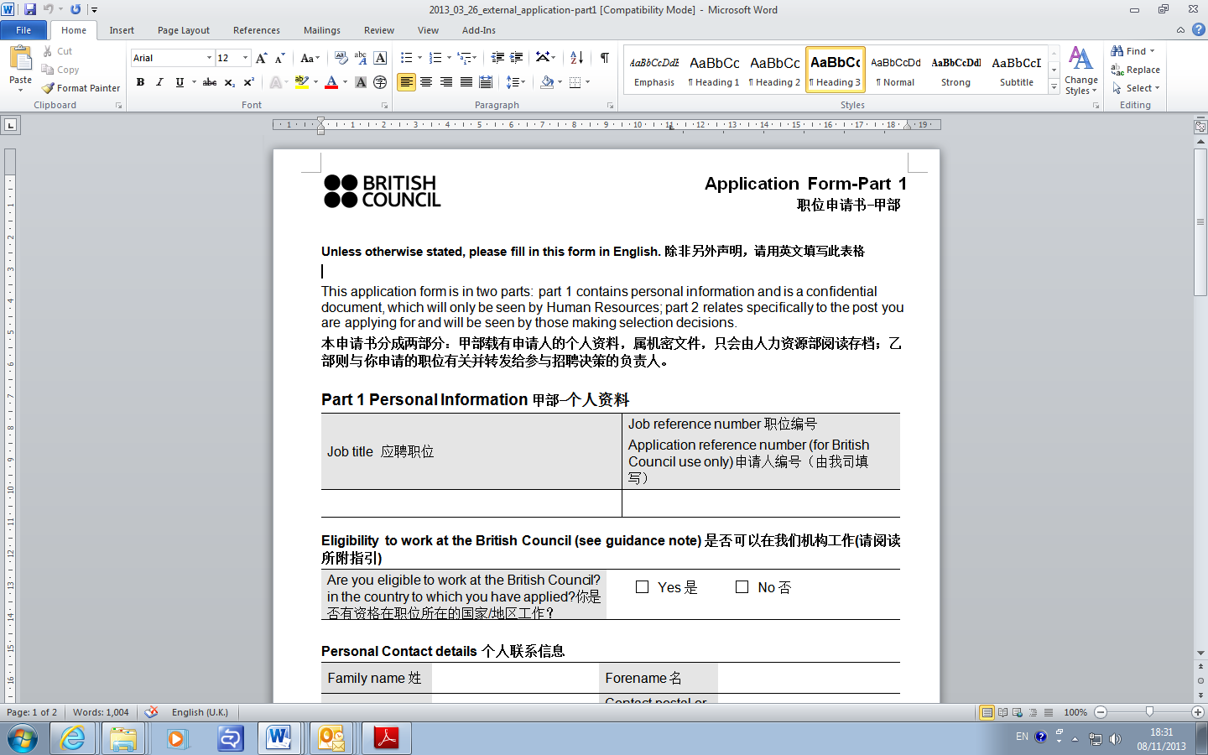

**Unless otherwise stated, please fill in this form in English. 除非另外声明，请用英文填写此表格**

**Part 1 Personal Information甲部-个人资料**

|  |  |
| --- | --- |
| **Job title 应聘职位** | **Job reference number 职位编号**  **Application reference number (for British Council use only) 申请人编号（由我司填写）** |
|  |  |

Eligibility to work at the British Council是否可以在我们机构工作

|  |  |
| --- | --- |
| Are you eligible to work at the British Council in the country to which you have applied? 你是否有资格在职位所在的国家/地区工作？ | Yes 是  No 否 |
| Nationality 国籍 |  |

**Personal details 个人信息**

|  |  |  |  |  |
| --- | --- | --- | --- | --- |
| Surname姓 |  | First Name(s) 名 |  | |
| Gender  性别 | Female 女  Male 男 | Date of Birth (dd/mm/yy)  生日（日/月/年） |  | |
| Title  称呼 | Ms 女士  Mrs 夫人  Mr 先生 | | | |
| Present address  联系地址 |  | Email Address  电子邮箱 |  | |
| Mobile  手机 |  | Telephone (Work&Home)  工作与家庭电话 |  | |
| First Language  母语 |  | Date of Application (dd/mm/yy)  申请日期 （日/月/年） | |  |

Criminal Convictions 犯罪记录

|  |  |  |  |  |  |
| --- | --- | --- | --- | --- | --- |
| Have you ever been convicted of a criminal offence?  你是否曾被刑事定罪？ |  | Yes是 |  | No否 | If yes, please give details of the offence and the sentence imposed  如答案为“是”，请详述犯罪事实与判罚。 |

**If you are applying for a job which clearly states involvement with children or young people, or a teaching job, please additionally complete this section.** *As these positions are exempt from the Rehabilitation of Offenders Act 1974, please detail below all convictions, cautions and bindovers, including those regarded as ‘spent’.*

**如果你申请的这个职位清楚地列明工作的内容会涉及到儿童和青少年，请完成此栏。***根据1974年的犯罪康复法案，这些人群可以被豁免。请详细在下栏列出所有被定罪，警告或勒令出庭的信息。*

|  |
| --- |
|  |

I declare that I have not been convicted, nor had any criminal proceedings against me, nor have I been warned, either orally or in writing, in relation to a sexual offence or child abuse. I declare that there are no such proceedings pending against me at the date of this declaration. I know of no reason why I should be considered unsuitable for work with children, the elderly or disabled, and I have not been dismissed from such a post for malpractice.

我谨声明我从未因为性侵犯或虐童而被定罪，或引起法律诉讼，或被口头或书面警告。我谨声明时至今日没有任何针对我的类似法律诉讼。我不知道有任何的原因导致我不适合与儿童、老人或残障人士一起工作，我也从没有因为这方面的原因而被除职。

I agree and hereby consent to the British Council seeking clearance from the CRB or appropriate agency. I understand that the British Council will not carry out these checks unless an offer of employment is made in writing to me.

我在此同意贵司从犯罪登记机构或相关部门核实我的无犯罪记录信息。我理解除非贵司已通过书面形式确认会录用我，否则此种核实不会进行。

|  |  |  |  |
| --- | --- | --- | --- |
| Your Signature/name  签名/姓名 |  | Date  日期 |  |

N.B Typing your name will be taken as being as binding as your signature表上键入本人姓名将被视作等同亲笔签名。

DECLARATION OF CONFIDENTIALITY

I agree to observe the strictest security concerning Distribution exams test materials and related documents. I undertake not to discuss any details of the exam with anyone.

Date: Signature:

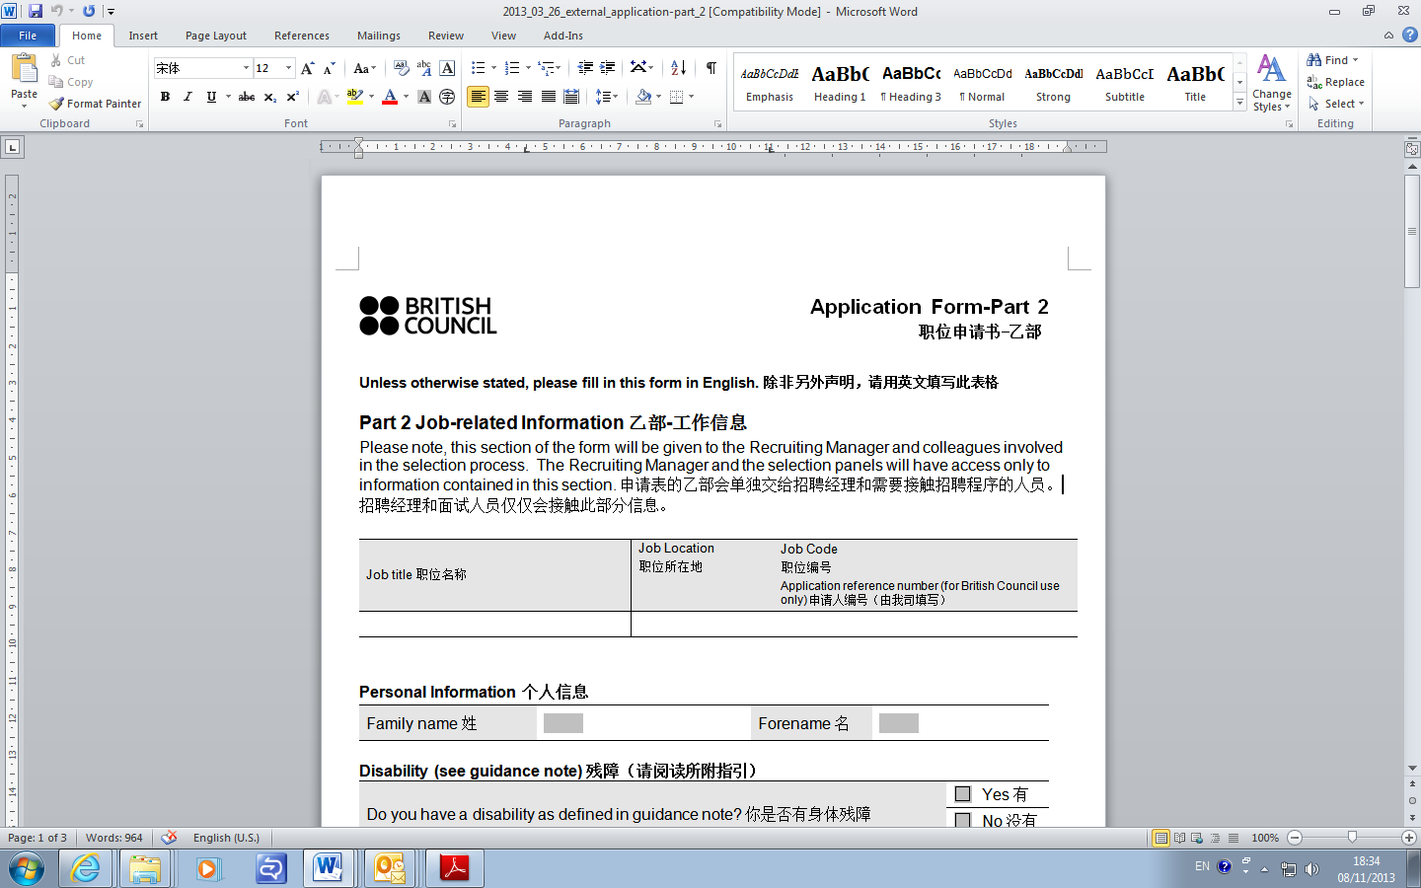

**Unless otherwise stated, please fill in this form in English. 除非另外声明，请用英文填写此表格**

**Part 2 Job-related Information 乙部-工作信息**

|  |  |  |
| --- | --- | --- |
| Job title职位名称 | Job Location  职位所在地 | Job Code 职位编号  Application reference number (for British Council use only) 申请人编号（由我司填写） |
|  |  |  |

**Personal Information 个人信息**

|  |  |  |  |
| --- | --- | --- | --- |
| Surname姓 |  | First name(s) 名 |  |

Employment and professional information

就业和职业信息

|  |  |  |  |
| --- | --- | --- | --- |
| Date (from / to)  起止时间 |  | Job Type  工作性质 | Full-time 全职  Part-time 兼职 |
| Job title and company/organisation  职位与公司/机构 |  | | |
| Duties (please limit to 3 main points, max 100 words)  简述所取得的主要成就，不超过三点，总共不超过100字。 |  | | |

|  |  |  |  |
| --- | --- | --- | --- |
| Date (from / to)  起止时间 |  | Job Type  工作性质 | Full-time 全职  Part-time 兼职 |
| Job title and company/organisation  职位与公司/机构 |  | | |
| Duties (please limit to 3 main points, max 100 words)  简述所取得的主要成就，不超过三点，总共不超过100字。 |  | | |

|  |  |  |  |
| --- | --- | --- | --- |
| Date (from / to)  起止时间 |  | Job Type  工作性质 | Full-time 全职  Part-time 兼职 |
| Job title and company/organisation  职位与公司/机构 |  | | |
| Duties (please limit to 3 main points, max 100 words)  简述所取得的主要成就，不超过三点，总共不超过100字。 |  | | |

Education/qualifications 教育背景/资历

Please give details of **relevant** educational and professional qualifications in chronological order.

请按时间顺序详述**相关**教育背景及获取的专业资格

|  |  |
| --- | --- |
| Qualifications获颁授的资格 | Dates时间 |
|  |  |
|  |  |

English language certificates 英语语言证书

Please give details of **relevant** English language proficiency certificates in chronological order.

请按时间顺序详述**相关**教英语语言能力证书

|  |  |
| --- | --- |
| Qualifications获颁授的资格 | Dates时间 |
|  |  |
|  |  |

Other relevant experience 其它相关的经验

Please give details of any additional relevant professional or other experience.

请提供其它你认为**相关**的专业的或其它经验的信息。

|  |  |
| --- | --- |
| Relevant experience 相关经验 | Dates 时间 |
|  |  |
|  |  |

Experience as an Invigilator for recognised exams (national and international)

其它公认的考试的监考经验（全国或全球）

Please give details of any additional relevant Invigilator experience.

请提供其它你认为**相关**的监考经验信息。

|  |  |  |
| --- | --- | --- |
| Subject / Scheme 科目 | Examining / Validating body 考试 | Dates or Times 时间或总次数 |
|  |  |  |
|  |  |  |

Work/Academic referee 工作/教育证明人

Please give details of 3 referees.

|  |  |  |  |
| --- | --- | --- | --- |
| Name of reference  证明人姓名 |  | Employer  雇主 |  |
| Job title / position  职称/职位 |  | Email address  证明人邮箱地址 |  |
| Telephone no.  证明人电话号码 |  | Please indicate if this is a work or academic reference  请指明这是工作或教育方面的证明人 |  |

|  |  |  |  |
| --- | --- | --- | --- |
| Name of reference  证明人姓名 |  | Employer  雇主 |  |
| Job title / position  职称/职位 |  | Email address  证明人邮箱地址 |  |
| Telephone no.  证明人电话号码 |  | Please indicate if this is a work or academic reference  请指明这是工作或教育方面的证明人 |  |

|  |  |  |  |
| --- | --- | --- | --- |
| Name of reference  证明人姓名 |  | Employer  雇主 |  |
| Job title / position  职称/职位 |  | Email address  证明人邮箱地址 |  |
| Telephone no.  证明人电话号码 |  | Please indicate if this is a work or academic reference  请指明这是工作或教育方面的证明人 |  |

Supporting statement附表

In support of your application, and referring to the job description and person specification, please tell us why you are suitable for this role. Your statement should not exceed 300 words.

根据你对这个工作的理解，请告诉我们为什么你适合做这份工作。请不要超过300字。

|  |
| --- |
| Supporting statement附表 |
|  |

Working availability工作时间

Please specify your working availability through the week from Monday to Sunday

请列出每周可工作的具体时间段

|  |  |
| --- | --- |
| Working availability through the week可工作时间 | Can you travel? 可否出差 |
| Mon周一  Tue周二  Wed周三  Thu周四  Fri周五 | 工作日：Yes 是  No 否 |
| Sat am 周六上午  Sat pm 周六下午 | 周末： Yes 是  No 否 |
| Sun am 周日上午  Sun pm 周日下午 |  |
| Comments (if any) 备注信息（如有）： |  |

Declaration

I declare that all the information I have provided in support of my application is, to the best of my knowledge and belief, correct and complete. 本人谨此声明此份申请表里所提供的信息，以我最好的知识和认知能力判断，是全面且正确无误的。

Warning: if you include any details that you know to be false or if you withhold relevant information, you may render yourself liable to disqualification from the recruitment exercise or, if appointed, to dismissal. 提醒：如果你提供了虚假的信息或隐瞒相关的资料，你将无权参与此次招聘，如果已聘用，将会被解雇。

|  |  |  |  |
| --- | --- | --- | --- |
| Your signature/name  签名/姓名 |  | Date  日期 |  |

**N.B Typing your name will be taken as being as binding as your signature**