**The Timeless Talent – British Artists’ Films from Past to Present**

**超越时间的天赋——英国艺术家影像展映**

艺术家影像一直是结合独特思维与艺术创新的艺术表达形式。广东时代美术馆与英国总领事馆文化教育处合作，精选呈现一系列英国艺术家的影像作品，涵盖经典与当代佳作，并邀请英国专门支持和推动艺术家移动影像实践的国际艺术机构LUX的项目总监吉尔·梁为观众解读艺术家的创作密码。Artist Film has always been an art form that condenses unique thoughts and creativity. In collaboration with the British Council, Guangdong Times Museum presents a series of video art pieces by British artists, ranging from classical experimental films to new works by young artists. The screenings will be introduced by Gil Leung, head of programme at LUX, an international arts agency that supports and promotes video artists.

**时间Time：**2014.4.19-4.20（星期六日/Saturday, Sunday）

**地点Venue：**广东时代美术馆，广州市白云大道北黄边北路时代玫瑰园三期 时代美术馆 1楼公共多功能厅 (地铁2号线黄边站D出口)

Public Multifunction Hall, 1st Fl., Guangdong Times Museum, Times Rose Garden Ⅲ, Huangbianbei Road, Baiyun Avenue, Guangzhou (Exit D, Huangbian Station, Line 2 of Guangzhou Metro)

**联合主办Organisers：** 英国总领事馆文化教育处 广东时代美术馆

**特别鸣谢Special Thanks to：**时代地产

**放映日程 Screening Schedule**

**4.19 星期六Sat.**

19:00-20:22GAZWRX: 杰夫·基恩电影集 *GAZWRX: The Films of Jeff Keen*

*Omozap 2*

*Marvo Movie*

*Like the Time Is Now*

*Rayday Film*

*Day of the Arcane Light*

*Cineblatz*

*The Dreams and Past Crimes of the Archduke*

*White Lite*

*Plazmatic Blatz*

*Wail*

*Blatzom*

*Artwar*

**4.20 星期日Sun.**

15:00-15:50 新材料：英国艺术家新影像 *New Materials, New British Artists' Video*

《1979年的沃尔沃斯唱诗班》*Woolworths Choir of 1979*

《 温暖如春的嘴唇》*Warm Warm Warm Spring Mouths*

《来杯茶吗？》*Wantee*

《 白种野蛮人的行进》*The March of the Big White Barbarians*

16:00-17:30 LUX项目总监吉尔·梁 公众讲座 Public Talk by Gil Leung, Head of Programmes, LUX

19:00-20:26 《 在海上的两年》*Two Years at Sea*

**影片简介 Film Synopsis**

**GAZWRX: 杰夫**·**基恩电影集**

**GAZWRX: The Films of Jeff Keen**

英国 UK/ 1960-1993/82’

本单元挑选了19世纪60至90年代的一系列短片，展现英国实验电影代表人物杰夫·基恩独树一帜且富有想象的电影摄制手法，他的创作在英国六十年代反文化和朋克浪潮后依然屹立不倒。他不忌讳谈论性和战争，敢于实验具有强烈感官体验的配乐以及粗犷的动画技术。

Jeff Keen's unique and imaginative filmmaking has outlived the various scenes in which it thrived, such as 1960s counter-culture and punk. This series of short films from the 1960s to the 1990s reveals the astonishingly tireless talent of a filmmaker not afraid to grapple with sex and war, or to experiment with visceral soundtracks and brutal animation techniques.

**Omozap 2**

1991/ 1’/ 彩色color/有声sound

杰夫·基恩身穿工装裤，在自己面前摆放好工具。他点亮一盏煤气灯，用锤子敲碎了盘子，在墙上画了一个巨大的神秘符号后，打开了电影放映机。这部视频短小精悍，时长仅为一分钟，为我们生动地再现了杰夫·基恩的真实经验，并把我们带入了一个富有灵感的蒙太奇世界。

Jeff Keen stands in overalls, poised with his tools before him. Then he lights a gas-fuelled torch, smashes a plate with a hammer, paints a giant esoteric symbol on the wall and starts up his film projector. This snappy one-minute video offers a neat evocation of the Jeff Keen live experience and throws us right into the inspired montages to come.

**Marvo Movie**

1967/ 5’/ 彩色color / 有声sound

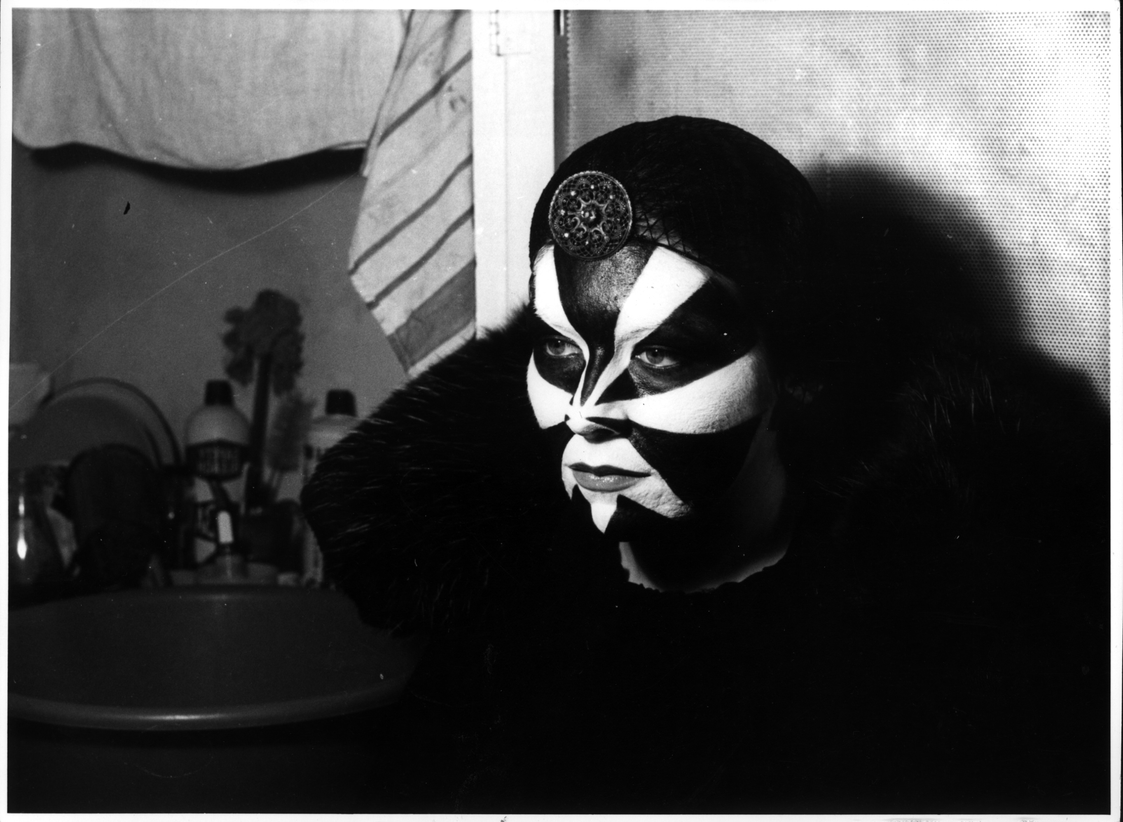肯·罗素谈到:“虽然这部影片让人不知所云，带有点胁迫感，但我就是喜欢。”猫女郎、米老鼠、可爱的玩具、当地墓园以及布莱顿的海滩……这些元素完全融汇在这出英式喜剧中，微妙地表达了挑衅和无政府主义。

Ken Russell said: "It went right over my head and seemed a little threatening, but I'm all for it." The Cat Woman, Mickey Mouse, melting toys, the local graveyard and Brighton beach all collide in this subtly provocative and anarchic bit of British fun.

**Like the Time Is Now**

1960/ 5’/黑白 b/w / 无声silent

镜头里呈现的是从美国来到英国布莱顿的三位“垮掉的一代”，边走边听唱片边吸着烟。随后，奇怪的礼帽凭空出现，一个卡通泡泡叫这帮人都去看电影。这象征着电影制作史上的全新时代的开启，以及更大规模的文化变革。

America comes to Brighton as three beatniks hang out, listen to records and smoke before strange hats appear out of nowhere and a cartoon bubble suggests they all go to the cinema. It is the beginning of a new era in filmmaking and a sign of the bigger cultural changes to come.

**Rayday Film**

1968-1970年、1976/13’/彩色color /有声sound

最初，基恩是想通过多重投影与现场表演相结合的方式来呈现，然而这部充满活力、以动作为主导的影片最终还是难以自已。在基恩的公寓里，他和他的朋友们拿着喷枪玩闹。接着他们去到布莱顿的海滩以及大大小小的街道上，到处喷绘达达式的标语，最后还占领了当地的垃圾站。  
Originally presented as a combination of multiple projections and live performance, this energetic, action-led film still barely manages to contain itself. Inside Keen’s flat, he and his friends make a racket with guns, then go out to spray Dada-esque slogans on the beach and streets of Brighton, taking in the local tip along the way.

**Day of the Arcane Light**

1969/13’/彩色 color/ 有声sound

继***Rayday Film***之后，杰夫·基恩团队的创作速度虽然有所减慢，但是他们却将当地的垃圾站（废物的最终目的地）脱胎换骨成了一个拥有无数可能的地方。在这部影片中，硬纸板制成的假手枪向轻松活泼的音乐射击；文字杀手莫特乐，手里攥着假阴茎，追赶一位身穿婚纱的女人。

Carrying straight on from *Rayday Film*, though at a slower pace, the Jeff Keen gang transforms the local tip - the final destination for anything unwanted – into a site where anything is possible. Cardboard guns are fired to jaunty music, and Motler the Word Killer, clutching a fake penis, runs after a woman in a wedding dress.

**Cineblatz**

1967/3’/彩色color /有声sound

清晰的静态噪音声中引出一组动态画面，其中包括动画版的超级英雄、广告、甚至还有英国上议院。影片在不到三分钟内展示了二十余个独立而个性鲜明的动态画面。

Sculpted radio static washes over a rush of animated superheroes, advertisements and even the House of Lords. More than twenty discrete bright animations appear in less than three minutes.

**The Dreams and Past Crimes of the Archduke**

1979-1984/7’/彩色color/有声sound

基恩的制作团队在这部唯美并带有神秘象征色彩的影片中展现了静谧与鬼魅。该部融合了黑色电影风格的惊悚片讲述的是在布莱顿火车站，女艺术家用纸圈制作了一个破碎的心脏。这部由红蓝两色结合而成的电影杰作令人在脑海中形成冥想的氛围，在基恩的所有电影创作中是独一无二的。

The Keen players turn quiet and ghostly in this beautiful and magically symbolic film. Incorporating a noir-style thriller at Brighton train station and an artist who creates a broken heart using her paper quill, this masterpiece in red and blue conjures up an atmosphere of contemplation not found elsewhere in Keens work.

**White Lite**

1968/3’/彩色color /有声sound

这是一部向《反物质人》和《原子人之怪兽娶亲》致敬的超现实并带有迷幻色彩的B级片(即拍摄时间短暂且低制作预算的影片)。该片描述的是一名半裸女人经历的奇异心灵之旅，带领着我们穿过各种嘈杂的密集声响，以及富有异国情调的蝙蝠标本。

Meet *Anti-Matter Man* and the *Bride of the Atom* in this surreal and psychedelic B-movie homage. A half-naked woman undergoes a strange inner journey that leads us through a barrage of film noise to exotic images of stuffed bats.

**Plazmatic Blatz**

90年代 1990s/9’/彩色color /有声sound

隐形轰炸机群如兀鹫般朝着汹涌的海浪和一片废墟之地猛冲过去。基恩利用特写镜头及多个厚重的视频图层，为观众呈现了一部极具感官体验的末日决战。

Stealth bombers swoop like vultures over crashing waves and a ruined land. Using found footage and several thick layers of video, Keen presents a very visceral version of Armageddon.

**Wail**

1961/ 5’/黑白b/w /无声silent

在这部集动作和动画于一体的非凡影片中，凶残帮派暴力的现实与战争图景，以及恐怖电影《狼人》有机地融合。基恩表达的是不同的文化形式之间的动态联系，以及主流文化可能是暴力与颠覆背后的主因。

The realities of brutal gang violence collide with war paintings and a horror movie *Werewolf* in this extraordinary action and animation mix. Keen recognizes the dynamic links between different cultural forms plus popular culture's potential for violence and subversion.

**Blatzom**

1983-1986/12’/ 彩色color /有声sound

杰夫·基恩戴上纸质口罩，身穿针织的“艺术战争”外套。在躲过了飞落的炸弹后，行走于灰暗、尘土飞扬、如月球一般的场景。该片采用了精心制作的电影原声噪音以搭配开场时的爆炸场景。

Jeff Keen put on a paper mask and his knitted *Artwar* jacket, having already avoided falling bombs and paced a dusty, grey, moon-like landscape. *Blatzom* offers an exquisitely crafted noise-soundtrack to match its explosive opening.

**Artwar**

1993/6’/彩色color/有声sound

这部制作精美、极富力道的电影系列片成功地将家中爆炸和枪火的尖锐表演与当地垃圾站的绘画融汇一起。它是基恩所有创作主题中巅峰之作，有力地为我们展现了他看似无穷无尽的想象力。

This refined and punchy series of films combines explosions and gunfire with strident performances at home and painting at the local tip. Possibly the culmination of all Keen’s themes and a potent reminds his seemingly inexhaustible imaginative powers.

**新材料：英国艺术家新影像**

**New Materials, New British Artists' Video**

该系列的四部作品分别来自伊丽莎白·普莱斯、埃德·阿特金斯、马克·莱基以及劳里·普罗沃斯特，他们代表了高清晰度技术带来的崭新感官体验，以及英国艺术家在影像作品中如何充分融合技术的历史。

This series of four works by Elizabeth Price, Ed Atkins, Mark Leckey, and Laure Prouvost represents a new sensual engagement with HD, as well as convergent technological histories in British artists' video works.

**WoolworthsChoir.tiff1979年的沃尔沃斯唱诗班**

**Woolworths Choir of 1979**

伊丽莎白·普莱斯Elizabeth Price/2012/18’

该影像由三部分组成，将截然不同的素材糅入一部看似不协调的作品：教堂建筑的照片、流行音乐演出的网络视频剪辑以及关于1979年沃尔沃斯家具店大火的新闻报道。影片将现有文字、图像和声音资料编织成一部游走于社会历史与幻想之间的作品。

Comprising three parts, the video brings together distinct bodies of material into a dissonant assembly; photographs of church architecture, internet clips of pop performances and news footage of a notorious fire in a Woolworths furniture department in 1979. The video weaves together existing archives of text, image and sound to create a work that drifts between social history and fantasy.

伊丽莎白·普莱斯凭此作品获得了2012年度的特纳奖。

Elizabeth Price has won the 2012 Turner Prize for this work.

**温暖如春的嘴唇**

**Warm Warm Warm Spring Mouths**

埃德·阿特金斯Ed Atkins/2012/12’

WWWSM2.tif阿特金斯作品中千变万化的主人公与其说是不为人知，不如说是深不可测——他身份被隐藏，躯体被湮没。在海底深处的发光真空管中，他与鱼儿共眠。他代表了被压抑的人群中躁动的声音，以及不被理解的人群里的面孔（尽管这张面孔是人工架构的，有时还会隐藏在乱作一团、不断飞舞的发丝背后）。通过电子动作捕捉技术装置编织成网，并利用计算机动画技术加以润色，该图像生动地表达了真理的飘忽不定和难以表达，使得阿特金斯的探索引起人们实质而深刻的共鸣。动画师将对发丝的渲染称为实现计算机绘图逼真效果的终极前沿（以及难以企及的梦想）。如果发丝能正确地加以呈现，作品中的角色将立即变得栩栩如生；反之，作品将成为一件让作者声誉扫地的免费样品。阿特金斯创作的形象有意在两者间游走：有时断断续续地浮现出来，如挥之不去的潜意识记忆，有时则像是从深处至上漂浮的异物。然而，正如阿特金斯的所有作品一样，这种由于不确定因素产生的颤抖心情将不可磨灭地萦绕于观众心头，久久不能拭去。

Atkins‘shifty, protean protagonist is not so much undercover as in too deep – his identity hidden; his body immersed and submerged. Sleeping with the fishes in his luminescent vacuum at the bottom of the ocean, he is the unquiet voice of the repressed, the face of the unfathomable (albeit a face that is framed and sometimes lost behind its mass of tangled, swirling hair). Netted by digital motion capture techniques, and embellished through computer animation, the slipperiness of truth and the difficulty of its representation are vividly entwined in this image, lending Atkins’ investigations a material, almost forensic resonance. Animators speak of the rendering of hair as the final frontier (and the elusive grail) of computer graphic verisimilitude. Get it right and your character is immediately believable. Get it wrong and it is an instant, incriminating giveaway. Atkins’ figure drifts deliberately between the two: fitfully surfacing like a nagging subconscious memory, a foreign body floating up from the depths. As with all of Atkins’ work, however, that frisson of indeterminacy lingers indelibly, haunting and troubling the mind.

受哲尔伍德/电影与影像伞奖委托创作

Commissioned by the Jerwood/Film and Video Umbrella Award

**来杯茶吗？**

**Wantee**

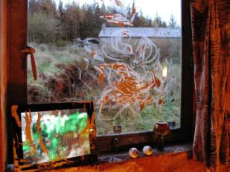劳里·普罗沃斯特Laure Prouvost/2012/15’

劳里·普罗沃斯特在格雷兹德尔艺术馆搭建了一所黑暗泥泞的房间，为该部影像作品提供了背景。该影片原为泰特英国美术馆的库尔特·施威特斯影响力展览中的参展作品之一。普罗沃斯特将该房间构想为她杜撰的祖父的起居室。该虚构人物被描述成一位概念派艺术家，同时也是施威特斯的密友。普罗沃斯特在作品创作中借鉴了施威特斯作品中的双重形式，即其著名的梅尔兹系列作品以及他传统的雕像画和风景画。因为施威特斯伴侣的口头禅是“来杯茶吗？“，所以”Wantee”成为了她的昵称。受到这一昵称的启发，这所房间也兼具茶室的主要特征。

Laure Prouvost created a dark muddy room at Grizedale Arts, which formed the setting for this video work which was originally presented as part of the exhibition at Tate Britain on the legacy of Kurt Schwitters. The room is conceived as the living room of Prouvost’s fictional grandfather. This invented relative is described as a conceptual artist and one of Schwitters’s close friends. Prouvost’s work draws upon the dual aspect of Schwitter’s work – his celebrated Merz works, as well as his conventional portraits and landscapes. The room also shares the features of a tea room, inspired by Schwitter’s companion’s nickname, Wantee, due to her habit of asking, ‘Want tea?’.

**白种野蛮人的行进**

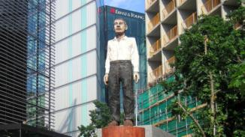**The March of the Big White Barbarians**

马克·莱基Mark Leckey/2006/5’

在莫里斯•勒梅特的具象诗中详细描述的《伦敦公共雕塑》，经由莱奇Jack Too Jack的自由阐释，化抽象为具体。

*London's Public Sculptures* are articulated by concrete poetry of Maurice Lemaitre in a free translation by Leckey's Jack Too Jack.

**在海上的两年**

**Two Years at Sea**

本·里弗斯Ben Rivers /2011 /86’ / 16mm /黑白b/w

一位叫杰克的男子独自居住在森林里。不管天气如何，他每天总要外出散步，并在充满迷雾的田野和树林里小憩。为了能不时在湖中心徜徉，他自己动手制作了一只小木筏。有时，他还开着破旧的吉普车去捡拾木材。一年四季，他都过着缩食节衣的生活，通过完成稀奇古怪的项目消磨时光，努力地实现他年轻时候激进的梦想。为了实现这个梦想，他在海上度过了两年时光。

A man called Jake lives in the middle of the forest. He goes for walks in whatever the weather, and takes naps in the misty fields and woods. He builds a raft to spend time sitting in a loch, drives a beat-up jeep to pick up wood supplies. He is seen in all seasons, surviving frugally, passing the time with strange projects, living the radical dream he had as a younger man, a dream he spent two years working at sea to realise.

《**在海上的两年》**曾获2011年2011年威尼斯电影节费比西奖以及哥本哈根纪录片电影节最高奖。

This film *Two Years at Sea* won the FIPRESCI Award at the Venice Film Festival 2011 and the top prize at CPH:DOX 2011.

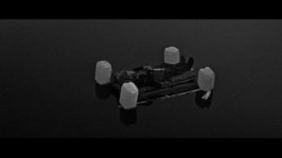

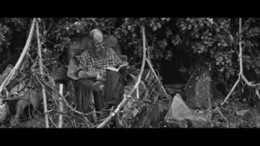

**讲座嘉宾Speaker Profile**

**吉尔**·**梁**

**Gil Leung**

吉尔·梁（1980年生于斯德哥尔摩，在伦敦居住和工作）是一名作家、艺术家及策展人。曾在英国泰特美术馆的电影和现场节目中担任助理策展人的她，目前则是伦敦艺术机构LUX的节目总监。她近期主持的展览和项目包括在伦敦Rowing画廊举办的“支持亦是反对”展，在伦敦Flat Time House美术馆举办的“交换”展，并与伦敦独立艺术空间Am Nuden Da合作举办个展“卧室之旅”,她还参与了奥伯豪森电影节。此外，她还为《究竟》、《艺术议程》、《长钉》等艺术杂志以及其他独立出版物撰稿。

Gil Leung (b. 1980, Stockholm, lives and works London) is a writer, artist and curator based in London. She previously worked as Assistant Curator for Tate Film and Live Programmes. She is Head of Programme at LUX, London. Recent exhibitions and projects include *For as Against at Rowing*, London, *Exchange* at Flat Time House, London, solo show *Bedroom Tour* in collaboration with Am Nuden Da, London, and works at Oberhausen Film Festival. She writes for *Afterall*, *Art Agenda*, *Spike* and other independent publications.

LUX是支持和推动艺术家的移动影像实践及其周边思想的国际艺术机构。 LUX旨在提供受众了解艺术家移动影像的机会，并发展受众；为移动影像艺术家的职业发展提供支持；促进并发展执业的话语权。成立于2002年，LUX的性质为慈善机构以及非营利有限责任公司。在英国，没有类似LUX的国际艺术机构。LUX拥有英国独一无二的艺术家电影和影像的众多收藏资源，也是该类收藏在欧洲最大的分销者（代表了从20世纪20年代至今约1,500艺术家的4,500件作品）。此外，LUX还与众多大型机构展开合作，包括博物馆、美术馆、艺术节和教育机构，以及直接面对公众和艺术家。

**LUX** is an international arts agency for the support and promotion of artists’ moving image practice and the ideas that surround it. LUX exists to provide access to, and develop audiences for, artists' moving image work; to provide professional development support for artists working with the moving image; and to contribute to and develop discourse around practice. Founded in 2002 as a charity and non-profit limited company, LUX is the only organisation of its kind in the UK. It represents the country’s only significant collection of artists’ film and video and is the largest distributor of such work in Europe (representing 4,500 works by approximately 1,500 artists from the 1920s to the present day). LUX works with a large number of major institutions, including museums, galleries, festivals and educational establishments, as well as directly with the public and artists.